# Module Four

# Milestone Two

# Grandfield College

Andrew Robinson

IT 650: Principles of Database Design

Southern New Hampshire University

August 22, 2024

Daniel Foster

## Conceptual Model

Preliminary Entities and Attributes

**Software**

SoftwareID (PK)

SoftwareTypeID (FK)

**SoftwareType**

SoftwareTypeID (PK)

**License**

LicenseID (PK)

SoftwareID (FK)

**Installation**

InstallationID (PK)

SoftwareID (FK)

UserID (FK)

**Request**

RequestID (PK)

UserID (FK)

**User**

UserID (PK)

**AuditLog**

LogID (PK)

UserID (FK)

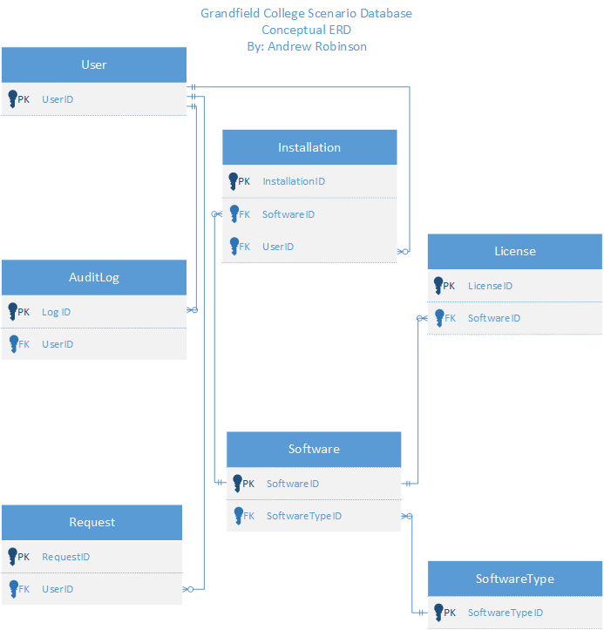

## Logical Model

Preliminary Entities and Attributes

**Software**

SoftwareID (PK)

SoftwareTypeID (FK)

Name

Version

Company

**SoftwareType**

SoftwareTypeID (PK)

Type

**License**

LicenseID (PK)

SoftwareID (FK)

LicenseType

StartDate

EndDate

Terms

Pricing

PricingUnit

**Installation**

InstallationID (PK)

SoftwareID (FK)

UserID (FK)

Location

InstallDate

RemovalDate

**Request**

RequestID (PK)

UserID (FK)

Software

RequestDate

Software

Reason

Response

ResponseDate

Status

**User**

UserID (PK)

Name

Location

Role

**AuditLog**

LogID (PK)

UserID (FK)

Action

Timestamp

Details

## 

## 

## 

## 

## 

## 

## 

## 

## 

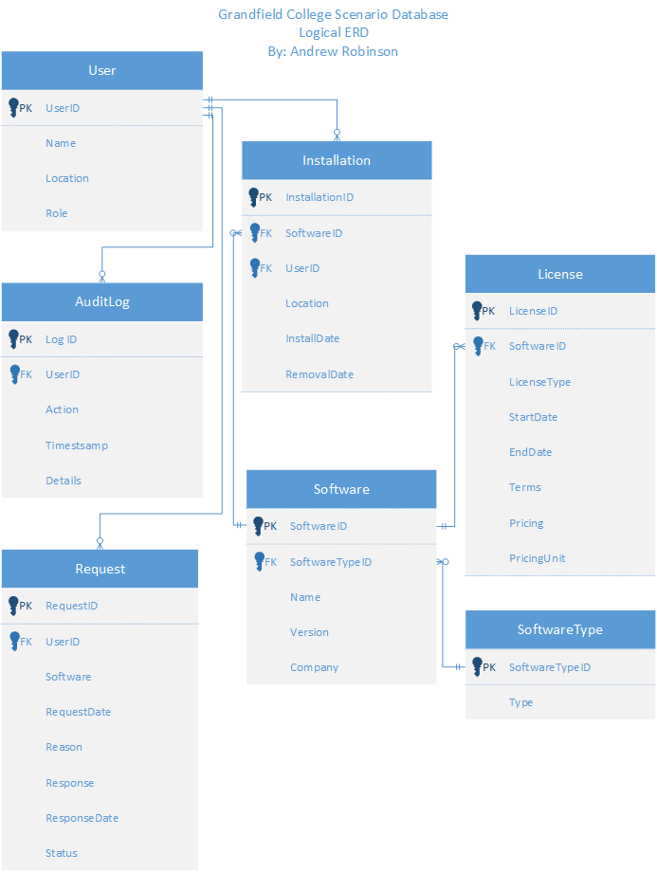

## Physical Model

Preliminary Entities and Attributes

**Software**

SoftwareID (PK) | nvarchar(50)

SoftwareTypeID (FK) | varchar(50)

Name | varchar(50)

Version | varchar(50)

Company | varchar(50)

**SoftwareType**

SoftwareTypeID (PK) | nvarchar(50)

Type | varchar(50)

**License**

LicenseID (PK) | nvarchar(50)

SoftwareID (FK) | nvarchar(50)

LicenseType | nvarchar(50)

StartDate | date

EndDate | date

Terms | varchar(MAX)

Pricing | float

PricingUnit | nvarchar(50)

**Installation**

InstallationID (PK) | nvarchar(50)

SoftwareID (FK) | nvarchar(50)

UserID (FK) | nvarchar(50)

Location | varchar(50)

InstallDate | date

RemovalDate | date

**Request**

RequestID (PK) | nvarchar(50)

UserID (FK) | nvarchar(50)

Software | varchar(50)

RequestDate | date

Reason | varchar(50)

Response | varchar(50)

ResponseDate | date

Status | varchar(50)

**User**

UserID (PK) | nvarchar(50)

Name | varchar(50)

Location | varchar(50)

Role | varchar(50)

**AuditLog**

LogID (PK) | nvarchar(50)

UserID (FK) | nvarchar(50)

Action | varchar(50)

Timestamp | datetime

Details | varchar(MAX)

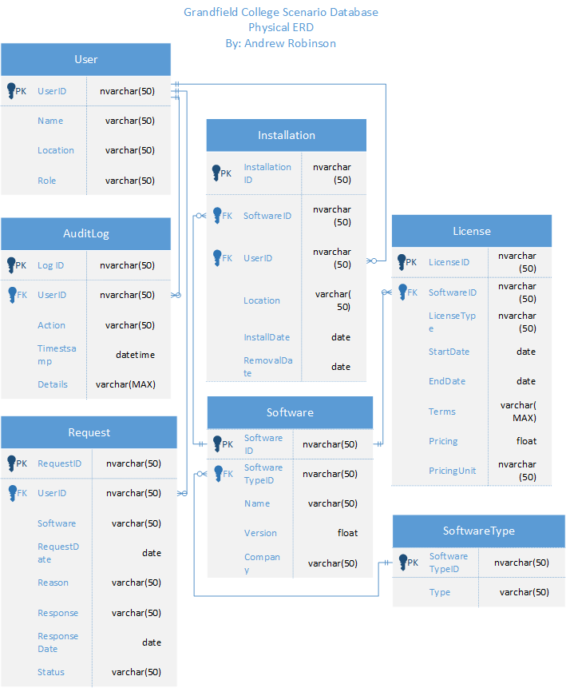

## 

## References

Conger, S. (2014). Hands-On Database (2nd ed.). Pearson Education (US). https://mbsdirect.vitalsource.com/books/9780133927078